TensorFlow is a famous deep learning library developed by Google Brain Team, which is widely used in many categories, such as search engines and translation. In this task, tensorflow library is used to build and train a DNN model for investigating the sentiment from 3000 to ~10000 twitter messages.

First of all, the necessary libraries would be included in the program.

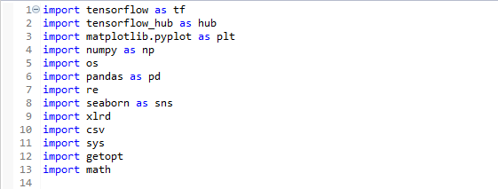

Noted that tensorflow_hub would also be included in this project to perform tensorflow learning with prepared module.

Next step is data preprocessing, each sentences would be divided into pieces of words. The words start with character “@” would be removed since the words in this pattern specify specific airline. Regular expression would also be used to remove special characters in each words.

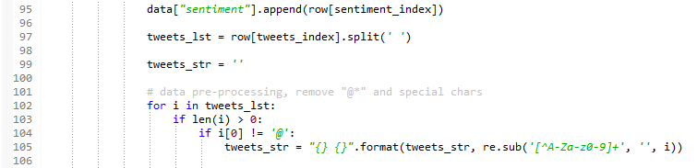

Then we add a polarity column and we simply embed the sentiments into 3 classes, “negative”, “positive” and “neutral” (the sentiment such as “very negative” would be re-classified), and transform them into numbers, so that fewer units are required in input layer.

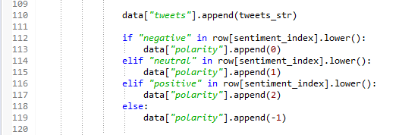

Forth, we convert the csv data into input function which can be recognized by tensorflow estimators, input function is a tuple of features and labels, feature is a dictionary of feature name(csv feature column) and label is an array of values.

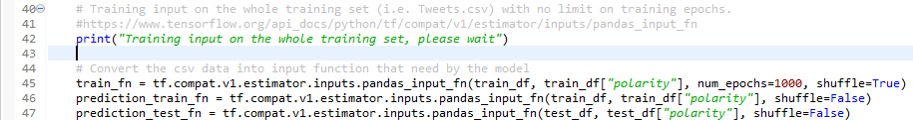

Then, we create an estimator object with the pre-processed feature columns, we choose Adgrad as the optimization algorithm to create the estimator.

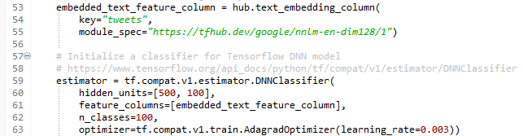

The characteristic of Adgrad is it can continuously adjust the learning rate (usually decrease) with the increase in iteration. Since lower learning rate is required to retrieve the extremum point, Adgrad algorithm has a higher efficiency than other optimization algorithm such as SGD.

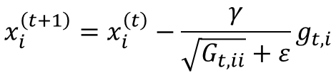Adgrad algorithm

“t” is the number of iterations

“ε” is a constant to prevent the denominator becomes 0

Finally, we use the build-in functions of the estimator object to perform training and evaluation of the accuracy.

